ENGLISH GRADE 2 WORKSHEET
REVISION 7

- Reorder the letters to make correct words. (Em hãy sắp xếp lại các chữ cái để được từ đúng)

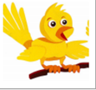  I  D  R  B  Bird | 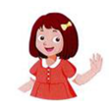  SI  I  T  R  E  S
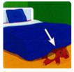  E  D  R  U  N | 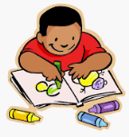  A  D  R  W
  M  H  B  U  T |   H  G  R  U  N  Y

- Odd one out (chọn từ khác loại)
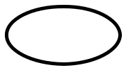
1. | happy | throw  sad tired  monkey elephant  on under  brother mum  school bus orange  bed sandbox
2. | teacher | lion
3. | bath | in
4. | dad | jump
5. | yellow | red
6. | pillow | shelf

d

III. Circle the correct option. (Em hãy khoanh tròn vào đáp án đúng)

1. | Who’s …...? – She’s my sister. | 4. | I ……… kick.
a. she |  | a. like
b. he |  | b. can
2. | What …...is this? | 5. | …... this? – It’s a blue bag.
a. color |  | a. Who’s.
b. colors |  | b. What’s.
3. | This is ……red blanket. | 6. | Where’s the book?
a. an |  | a. It’s my book.
b. a |  | b. It’s on the shelf.
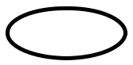

IV. Tick (√) the correct sentence. (Em hãy đánh dấu tick vào câu đúng)

- a. He’s my dad. √

b. He my dad.

2. a. This is an elephant.

b. This is a elephant.

3. a. I can’t sing.

b. I like sing.

4. a. What color is this?

b. Who color is this?

5. a. You are thirsty?

b. Are you thirsty?

6. a. It’s a orange flower.

b. It’s an orange flower.

V. Read and color the picture. (Em hãy đọc và tô màu bức tranh)
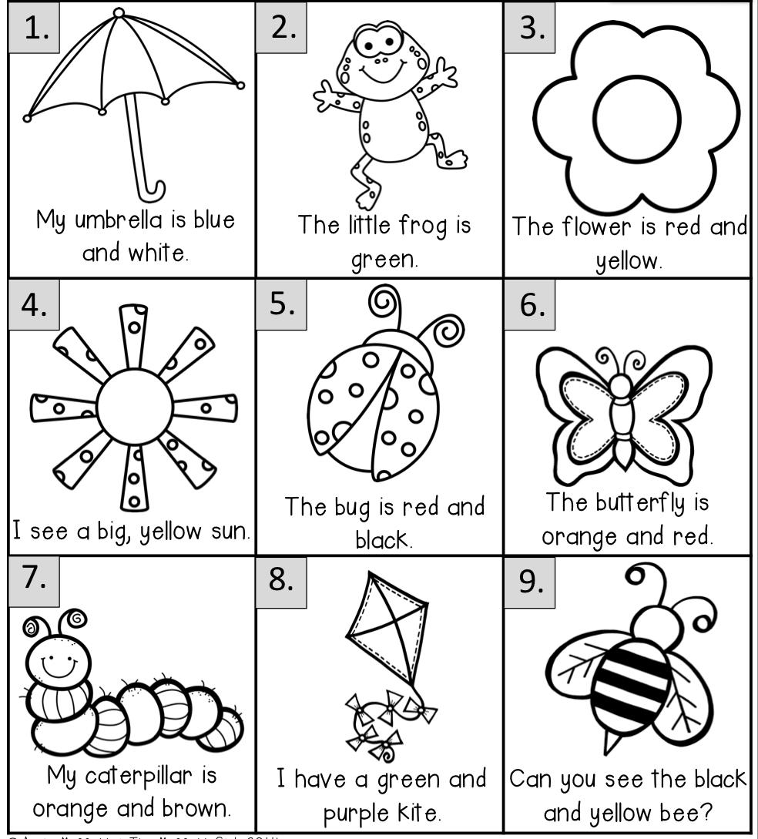

---- The end ----

