Name:…………………………………….

Class:………………………………………

**WORKSHEET ENGLISH GRADE 3 – REVISION 6**

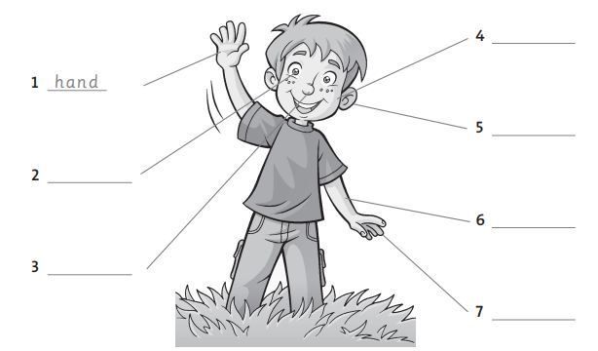**I. Look and write**

***This is These are***

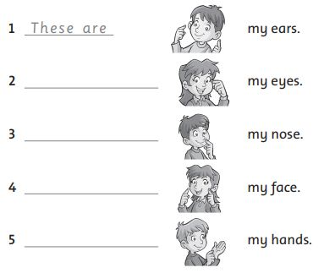**II. Write**

**III. Read then colour**

The face is orange. The eyes are green. The arms are blue. The hair is red. The nose is pink. The legs are blue. The hands are yellow. The ears are brown.

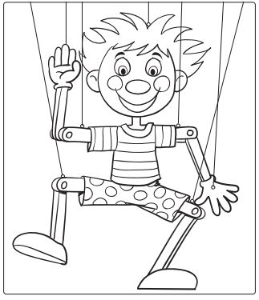

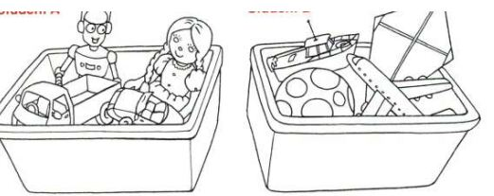**IV. Look. Tick (V)**

**Picture 2**

**Picture 1**



Picture 1

Picture 2

V

v

1. car

v

v

2. boat

v

v

3. ball

v

4. doll

v

v

v

5. kite