Name:…………………………………….

Class:………………………………………

**ENGLISH GRADE 4 WORKSHEET – REVISION 6**

1. **Write the words**

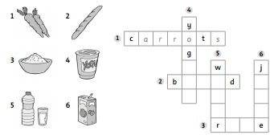

[](javascript:edit(29011))**II. Write questions and answer.**

[](javascript:edit(4244))[](javascript:edit(150298))a. _*Do you like_______________*? _Yes, ___________ .

[](javascript:edit(4245))b. _________________________? ____, ___________.

**My** and **your** say who owns something.

**I**  **my** train, **my** ball, **my** car

**You** **your** car, **your** train, **your** teddy

[](javascript:edit(4244))[](javascript:edit(4067))[Bread Clip Art](javascript:edit(3951))c. _________________________? ____, ___________.

d. __________________________? ____, __________.

**III. Write the words in the correct order.**

|  |  |  |  |
| --- | --- | --- | --- |
| 1. | do What like you ? | 2. | you Do like bananas ? |
| 3. | you Do fish like ? | 4. | you like do What ? |
|  |  |  |  |
| 5. | like I bread . | 6. | don’t I like bread . |
| 7. | like What you do ? | 8. | carrots I like don’t . |
|  |  |  |  |

**IV. Match**

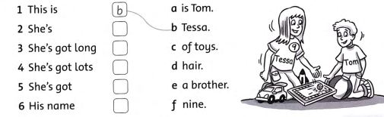

**V. Look and write. Use *It’s got* and words from the box.**

*long short triangle rectangle square*

