Name:…………………………………….

Class:………………………………………

**ENGLISH GRADE 1 WORKSHEET – REVISION 6**

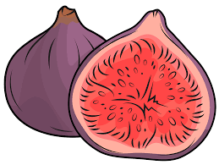**A. Circle the pictures that begin with the letter - F**

|  |  |  |
| --- | --- | --- |
| 1.jpg1. | 2. | 3. |
| 4. | 5.5.jpg | 6. |

**B. Circle the correct word**

|  |  |  |
| --- | --- | --- |
| 1.8.jpg | 2.17.jpg | 3.6.jpg |
| bin | two | boat |
| ball | three | picture |
| 4.7.jpg | 5.9.jpg | 6.10.jpg |
| window | doll | chair |
| balloon | car | table |
|  |  |  |

**C. Complete the words**

|  |  |  |
| --- | --- | --- |
| 1.a.jpg | 2.b.jpg | 3.4.jpg |
| ***r o b o*** t | e __ __ p __ __ __ t | b __ __ __ __ |
| 4.c.jpg | 5. | 6.21.jpg |
| __ e __ __ __  b __ __ __ | __ __ t __ | p __ c __ __ r__ |

**D. Look. Read then write “Yes” or “No”**

|  |  |  |  |
| --- | --- | --- | --- |
| 1. | d.jpg | This is my chair. | _______________  ***Yes*** |
| 2. | e.jpge.jpg | Two doors. | _______________  ***No*** |
| 3. |  | It’s an elephant. | _______________ |
| 4. | 7.jpg7.jpg7.jpg | Three balloons. | _______________ |
| 5. | 5.jpg | It’s a fan. | _______________ |
| 6. |  | This is your table. | _______________ |