Name:…………………………………….

Class:………………………………………

**ENGLISH GRADE 4 WORKSHEET – REVISION 5**

**I. Read, draw and colour.**

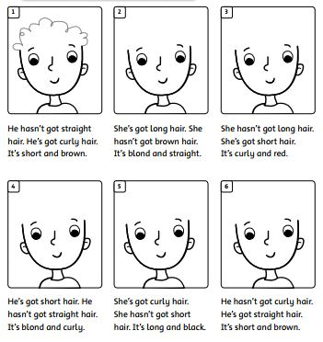

She hasn’t got long hair. She’s got short hair. It’s curly and red.

She’s got long hair. She hasn’t got brown hair. It’s blond and straight.

He hasn’t got straight hair. He’s got curly hair. It’s short and brown.



He hasn’t got curly hair. He’s got straight hair. It’s short and brown.

She’s got curly hair. She hasn’t got short hair. It’s long and black.

He’s got short hair. He hasn’t got straight hair. It’s blond and curly.

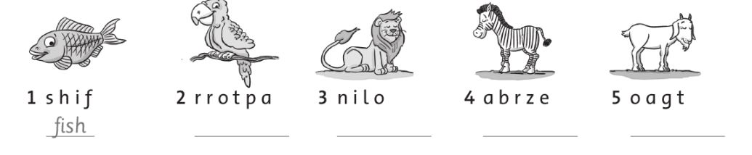**II. Write**

**III. Circle the odd-one-out.**

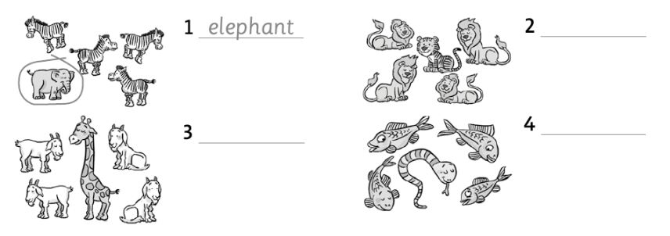

**IV. Circle the picture that rhymes. Write.**

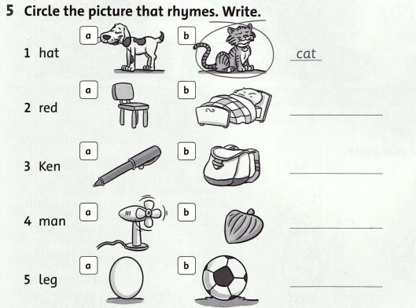

[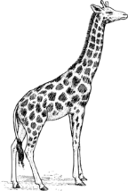](javascript:edit(66697))V. Write the sentences. I like giraffes. They’re tall.

[](http://www.google.com/imgres?hl=en&client=gmail&rls=gm&biw=1024&bih=540&tbs=itp:clipart&tbm=isch&tbnid=9ulhbYOawmXXeM:&imgrefurl=http://www.facebook.com/Idontlikeanything&docid=Egl2P--b7axnAM&imgurl=http://a1.sphotos.ak.fbcdn.net/hphotos-ak-snc6/s320x320/264633_193784170672290_193781287339245_568944_5000216_n.jpg&w=320&h=320&ei=RO3rTvPxFezymAXgxtmKCg&zoom=1)[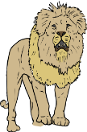](javascript:edit(13980))[](javascript:edit(8566))[](javascript:edit(17903))[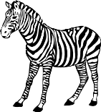](javascript:edit(11751))

[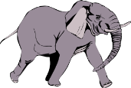](javascript:edit(3109))

* I don’t like ___________
* ___________________
* ___________________
* I like _____________
* _________________
* _________________