Name:…………………………………….

Class:………………………………………

**ENGLISH GRADE 1 WORKSHEET – REVISION 5**

**I. Look and circle**

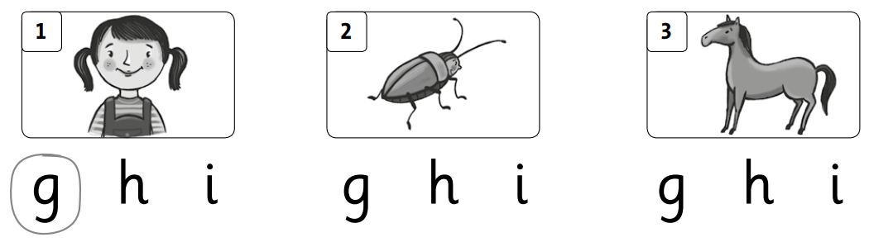

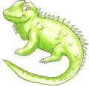

**5**

**4**



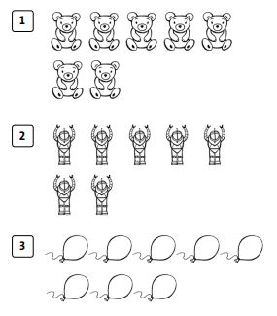**II. Count and tick (√)**

√

Eight

Seven

Eight

Seven

Eight

Seven

**III. Match**

|  |  |  |
| --- | --- | --- |
| 1.1.jpg | a. pencil  b. pencil box | 4. |
| 2.2.jpg | c. rubber  d. bag | 5.5.jpg |
| 3.3.jpg | e. lunch box  f book | 6.6.jpg |
|  | g. water bottle | 7. |

**IV. Complete the sentences and answer.**

|  |  |  |  |
| --- | --- | --- | --- |
| 1. | ***How old are you*** ? | 8.jpg | I’m ____________  ***one*** |
| 2. | How old are _______ ? | 9.jpg | I’m ____________ |
| 3. | How old ______ ______? | 10.jpg | I’m ____________ |
| 4. | How _____ ______ ______? | 11.jpg | I’m ____________ |