Name:…………………………………….

Class:………………………………………

**ENGLISH GRADE 4 WORKSHEET – REVISION 4**

**I. Find the odd-one-out. Circle. The write and say.**

*He’s/ She’s got……. long/ short/ curly/ straight/ brown/ blond hair.*

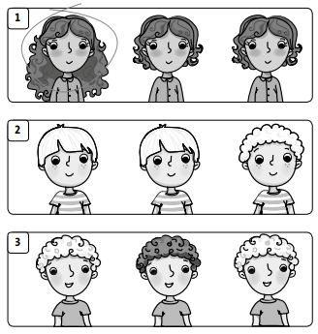

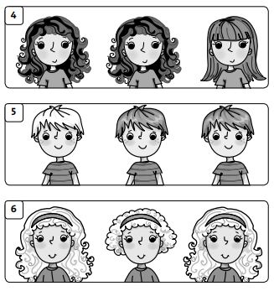

*_______ .*

*_______ .*

*_______ .*

*_______ .*

*He’s got .*

*She’s got long hair .*

**II. Colour and write.**

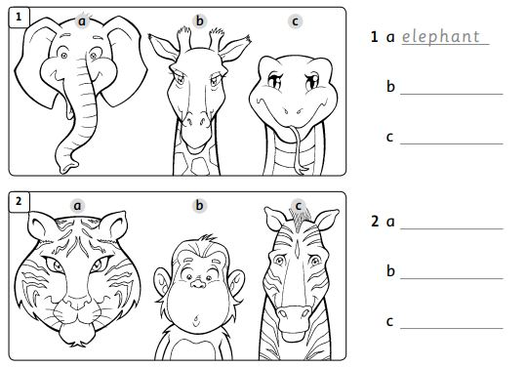

**III. Circle the adjective. Write T (True) or F (False)**

**F**

*________*

1. Elephants are green .

*________*

2. Giraffes are tall.

*________*

3. Frogs are big.

*________*

4. Zebras are little.

*________ *

5. Lions are brown.

*________*

6. Monkeys are big.

*________*

7. Snakes are shorts.