Name:…………………………………….

Class:………………………………………

**WORKSHEET ENGLISH GRADE 3 – REVISION 4**

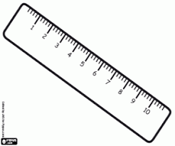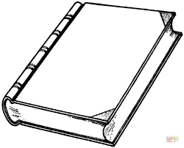**I. Circle the correct word.**

1

3

2

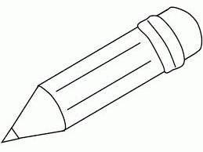

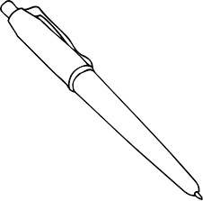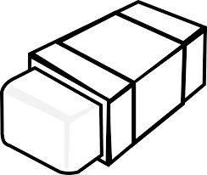

book / pen

rubber / pen

ruler / rubber

book / ruler

book / pencil

4

5

**II. Read and colour**

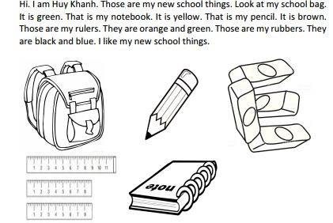Hi. I am Huy Khanh. Those are my new school things. Look at my school bag. It is green. That is my notebook. It’s yellow. This is my pencil. It is brown. They are my rulers. One is orange and two rulers are green. I’ve got four rubbers. They are black and blue. I like my new shool things.

**III. Read the text again and circle T (True) or F (False)**

1. Huy Khanh has got new school things.

F

T

F

T

1. The school bag is blue.

F

T

1. The notebook is yellow.

F

T

1. The rulers are red and green.

F

T

1. The rubbers are black and blue.

**IV. Write about the colour of your school things.**

