Name:…………………………………….

Class:………………………………………

**ENGLISH GRADE 1 WORKSHEET – REVISION 4**

**I. Circle the correct letter**

**e**

**a**

**d**

**b**

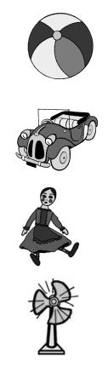

**II. Circle the correct number**

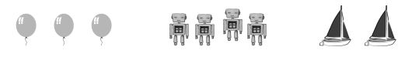

**d**

**b**

**e**

**c**

**f**

**d**

**a**

**b**

**d**

**a**

**c**

**f**

Three **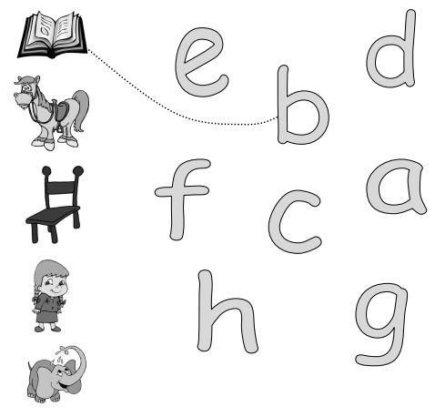****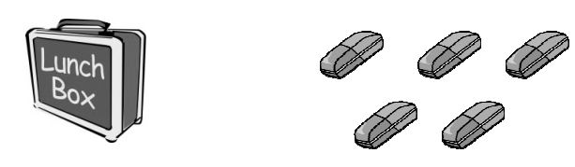**

Four

One

Two

Three

Two

Four

Two

One

Three

**III. Match**

Two

Six

Five

Five

Four

Six

Three

One

Six