Name:…………………………………….

Class:………………………………………

**ENGLISH GRADE 5 WORKSHEET – REVISION 3**

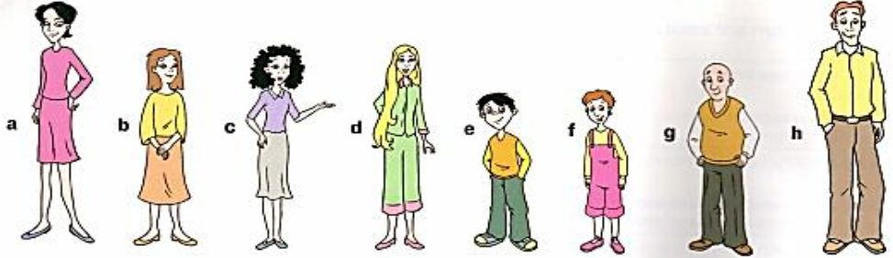**I. Match.**

**e**

1. I’ve got green eyes and black hair. I’m eight. …………..

2. My hair is brown and straight. I’m twenty. …………..

3. My hair is short and red and I’m tall. ……………

4. I’ve got long fair hair. …………..

5. I’m a very tall woman and I’ve got short black hair. ……………

6. I’ve got curly black hair. …………….

7. I’m short and I haven’t got any hair. I’m forty-two. …………….

8. My eyes are brown and I’ve got short brown hair. ……………..

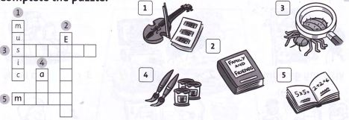**II. Complete the puzzle.**



**III. Read and write**

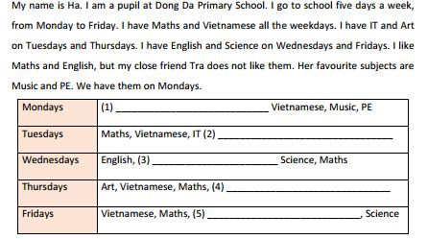

**IV. Reorder the words to make complete the sentences.**

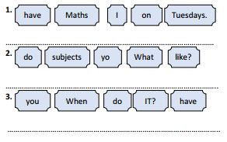

*IT (n): Tin học*