Name:…………………………………….

Class:………………………………………

**ENGLISH GRADE 4 WORKSHEET – REVISION 3**

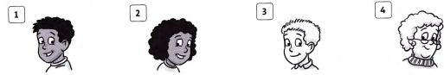**I. Circle the correct word.**

1. a. long b. short c. black

2. a. curly b. straight c. blond

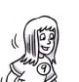3. a. blond b. black c. brown

4. a. curly b. short c. straight

5. a. straight b. black c. blond

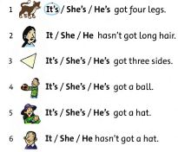**II. Read and circle**

**III. Look at the pictures and write the correct name next to each description.**

***Toby***

0. I’m 74 and I’ve got grey hair. I’m quite thin.

1. I’m 18. I’m tall and I’ve got long black hair.

2. My hair is short and fair. I’m 50 years old. I’m not very tall.

3. I’ve got short black hair. I’m tall and I’m a bit fat.

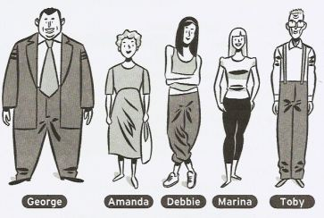4. I’m 16. My hair is blonde and long. I’m not very tall.

**IV. Make the sentences negative.**

0. He’s got a big ball. 🡺 He hasn’t got a big ball.

1. It’s got small eyes. 🡺

2. She’s got green socks. 🡺

3. I’ve got a brown bike. 🡺

4. They’ve got long rulers. 🡺