Name:…………………………………….

Class:………………………………………

**ENGLISH GRADE 1 WORKSHEET – REVISION 3**

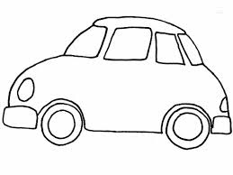**I. Write**

**Across:**

4

3

2

1

5

**Down:**

|  |  |  |  |  |  |  |  |  |  |
| --- | --- | --- | --- | --- | --- | --- | --- | --- | --- |
|  |  |  |  |  |  |  | b |  |  |
|  |  |  |  | 7 |  |  | 6 |  |  |
| ***t*** | ***e*** | ***d*** | ***d*** | ***y*** | ***b*** | ***e*** | ***a*** | ***r*** |  |
|  |  |  |  |  |  |  |  |  |  |
|  | 2 | d |  |  |  |  |  |  |  |
|  | 3 |  | b |  |  |  |  |  |  |
|  |  |  |  |  |  |  |  |  |  |
|  |  |  |  |  | 4 | c |  |  |  |

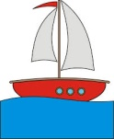

5

6

7

1

**II. Count then colour**

|  |  |  |  |  |  |  |
| --- | --- | --- | --- | --- | --- | --- |
| 1. | Three boats |  |  |  |  |  |
| 2. | Two dolls |  |  |  |  |  |
| 3. | Four cars |  |  |  |  |  |
| 4. | One balloon |  |  |  |  |  |

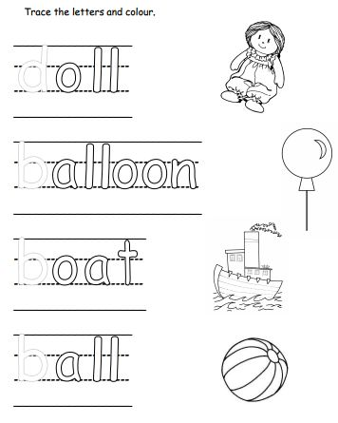**III. Trace the letters and colour.**