Name:…………………………………….
Class:………………………………………
WORKSHEET ENGLISH GRADE 3 – REVISION 2
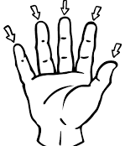
I. Complete the words
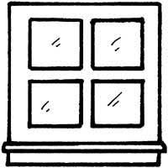
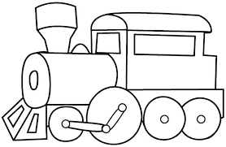
1. 2. 3.

w i n d o w
t __ __ __ n
f __ __ __ __ __s
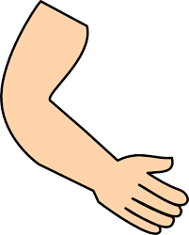
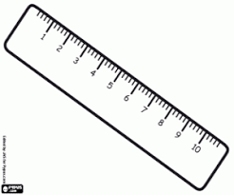
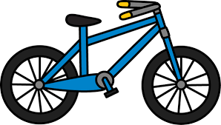
4. 5. 6.
a __ __
r __ __ __ r
b __ __ __

II. Circle the odd – one – out. Write
1. a. book b. rubber c. nine
2. a. eyes b. ball c. legs
3. a. pencil b. eight c. six
4. a. doll b. ears c. kite
5. a. puzzle b. face c. arms
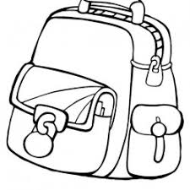
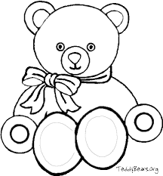

III. Write the word
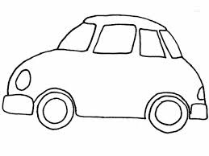
1. 2. 3. 4.
g a b
_____________

r a c
_____________

d t d e y
_____________

e s v e n
_____________

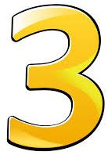
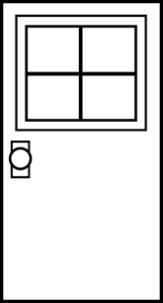
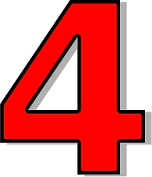
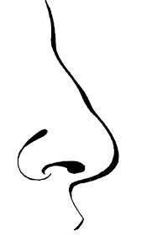
4. 5. 6. 7.
r t h e e
_____________

o d o r
_____________

r o u f
_____________

o n e s
_____________

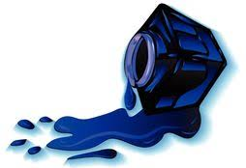
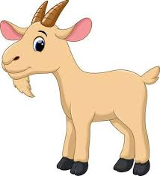
IV. Circle the correct first letter. Then write
ink
1. i l j ________ 2. e f g __________
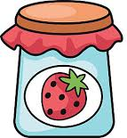
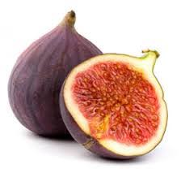
3. l j k ________ 4. e h f __________

V. Compete the sentences
This is your eyes These are Are
My is Is this old What
Are
1. _________________ you six? 6. These are my _______________.
2. _________________ is this? 7. How ________________ are you?
3. ________________ my nose. 8. These are ____________ rubbers.
4. ______________ your pen? 9. __________________ your balls.
5. _____________ pencil is blue. 10. _________________ your bag?
V. Answer
Yes,………….……………………………….
1. Is this a ruler?

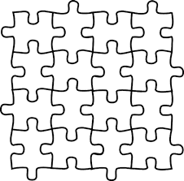
It’s ………….……………………………….
2. What’s this?

3. Is this a train? ___________________________________

4. What’s your favourite toy? ___________________________________

5. What colour is your rubber? ___________________________________

