Name:…………………………………….

Class:………………………………………

**ENGLISH GRADE 2 WORKSHEET – REVISION 2**

**I.Write the missing letters then match**

1. p i ll o w a. 

2. w _ rd _ ob _ b. 

3. sh _ l _ c. 

4. bl _ nk _ t d. 

5. b _ d e. 

6. s _ f _ f. 

7. l _ m _ g. 

8. pl _ n _ h. 

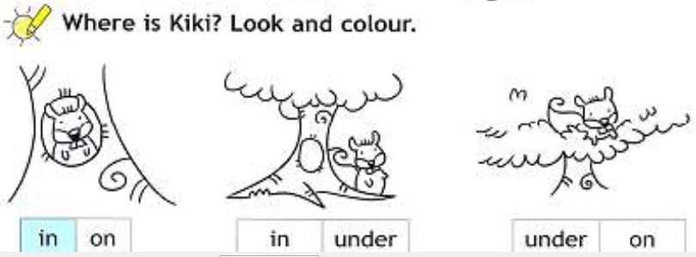**II.**

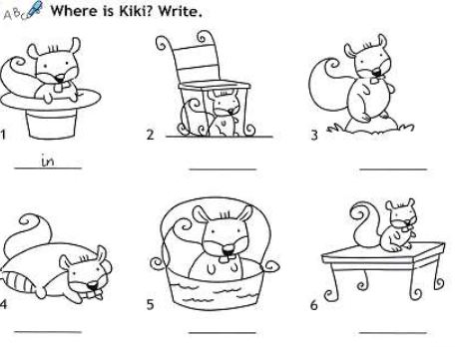**III.**

**IV. Reorder the letters to make correct words**

1. das: sad_________________

2. iedtr: ___________________

3. ytirths: ____________________

4. ryungh : ___________________

5. hto : ___________________

6. ldoc: ___________________

7. phappy : ____________________

**V. Write *Yes, I am* or *No, I’m not***

|  |  |  |  |
| --- | --- | --- | --- |
|  | A: Are you happy ?  B: Yes, I am |  | A: Are you happy ?  B: No, I’m not |
|  | A: Are you hungry ?  B: ____, ___________ |  | A: Are you tired ?  B: ______, ____________ |
|  | A: Are you hot ?  B: _____, __________ |  | A: Are you cold ?  B: ______, ___________ |