Name:…………………………………….

Class:………………………………………

**ENGLISH GRADE 5 WORKSHEET – REVISION 2**

**I. Circle the odd-one-out.**

1. a. art room b. Science c. maths d. PE

2. a. music room b. Sports field c. English d. playground

3. a. watch b. present c. play d. do

4. a. nuts b. pastries c. listen d. sweets

5. a. neighbour b. card c. balloon d. cake.

6. a. go b. afternoon c. get d. have

7. a. night b. morning c. visit d. evening

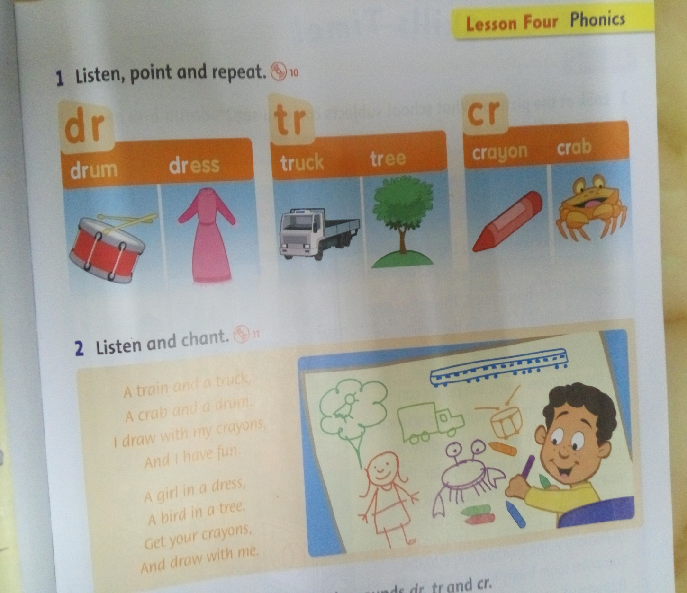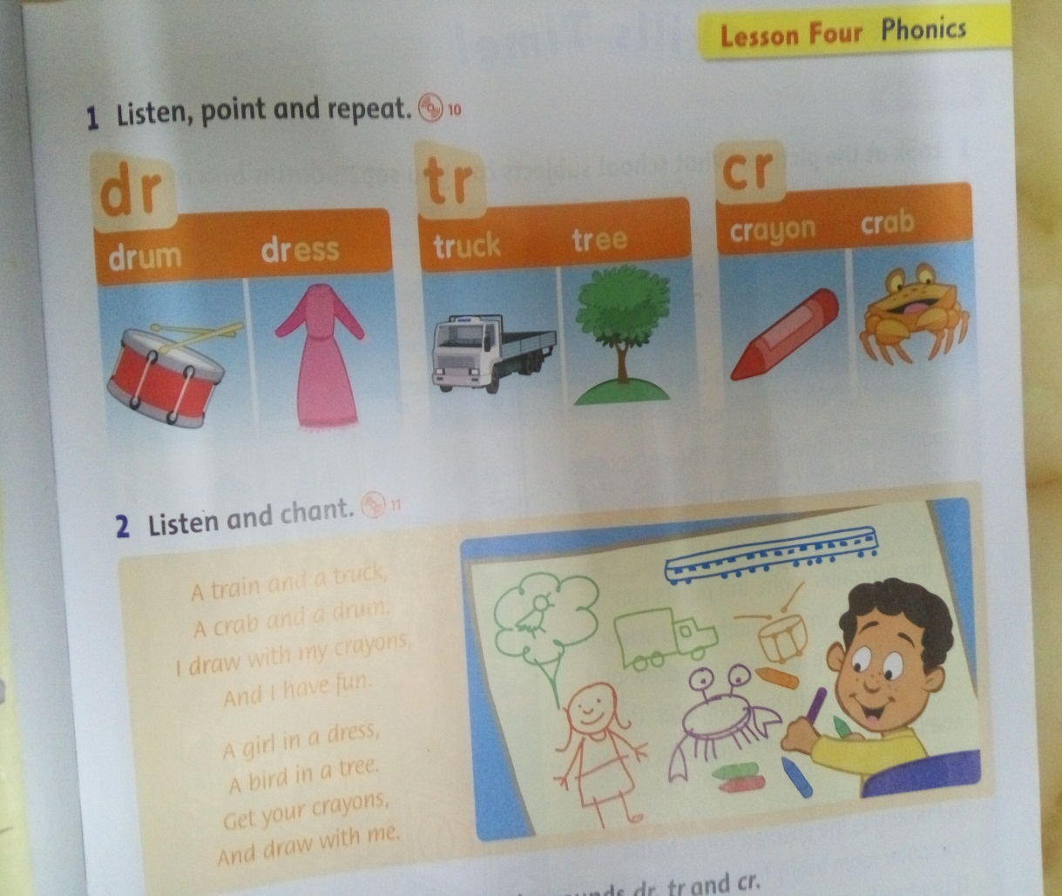**II. Circle the correct sound and write the word.**

drum

1. dr tr cr 2. dr tr cr

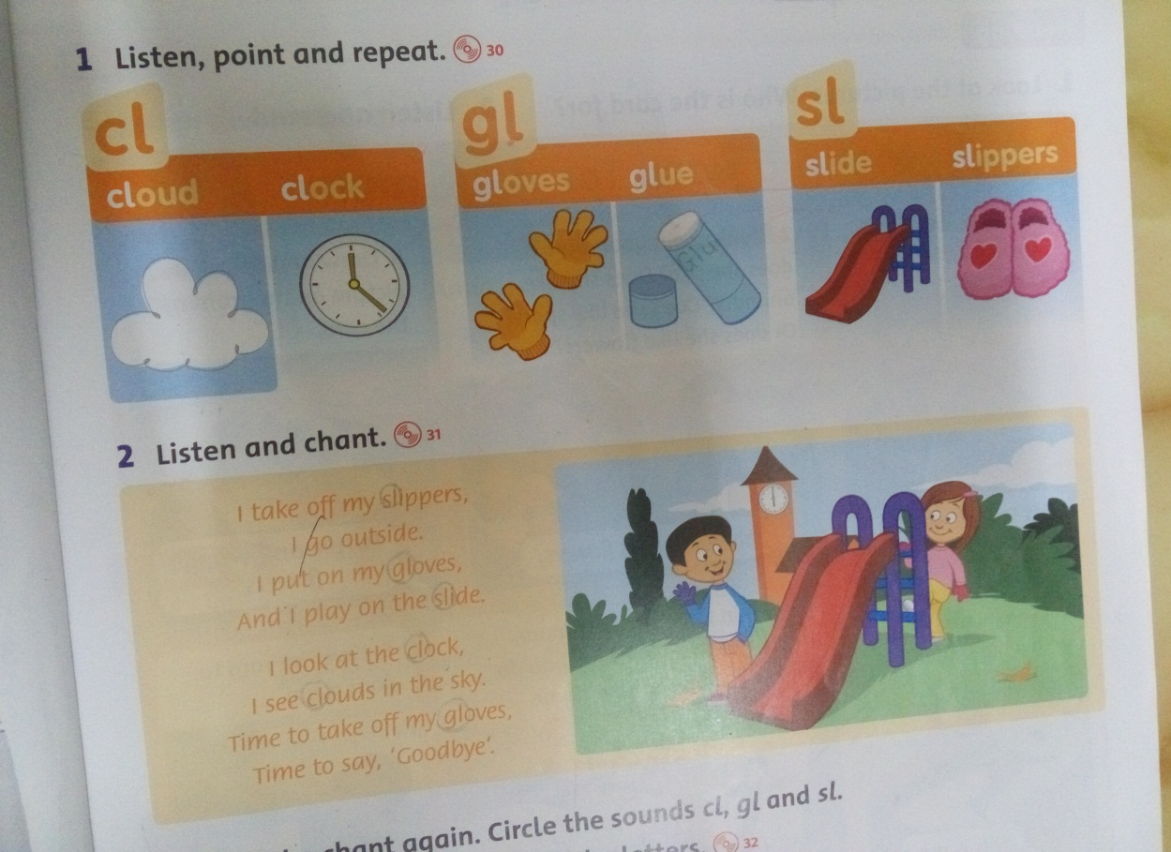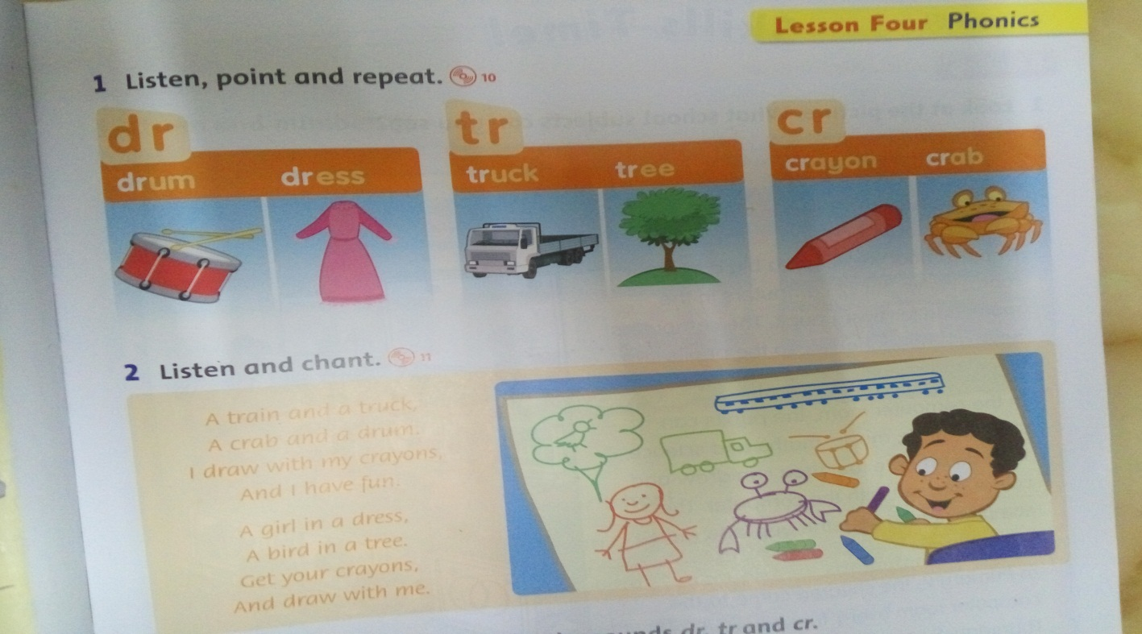

3. dr tr cr 4. cl gl sl

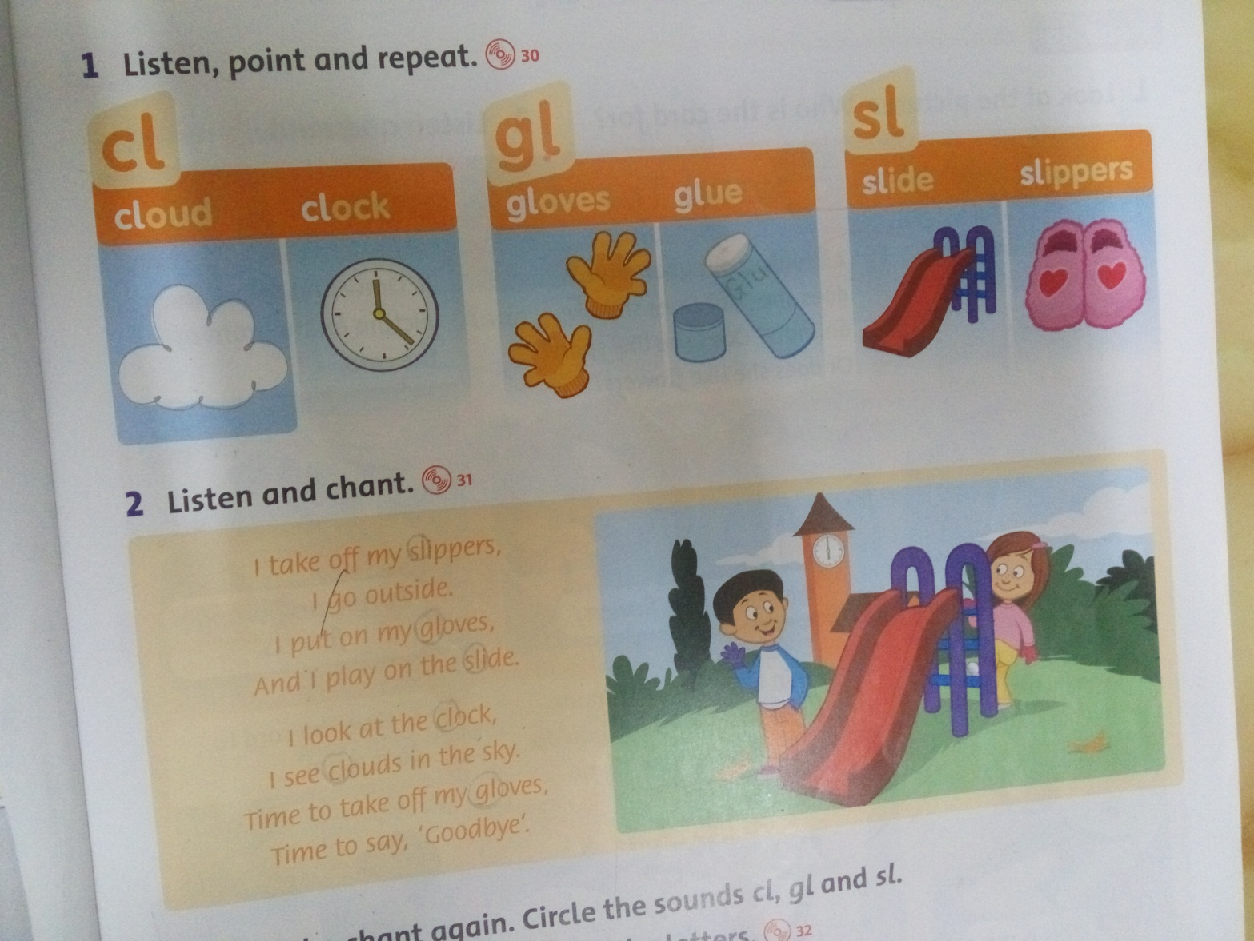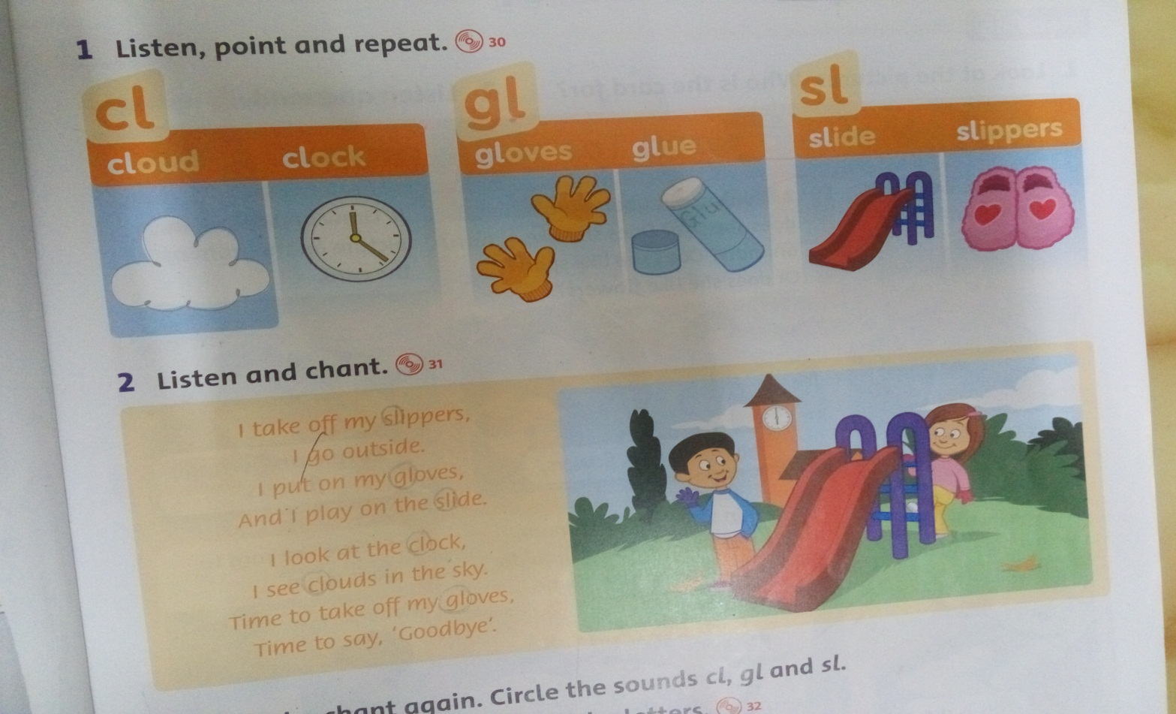

5. cl gl sl 6. cl gl sl

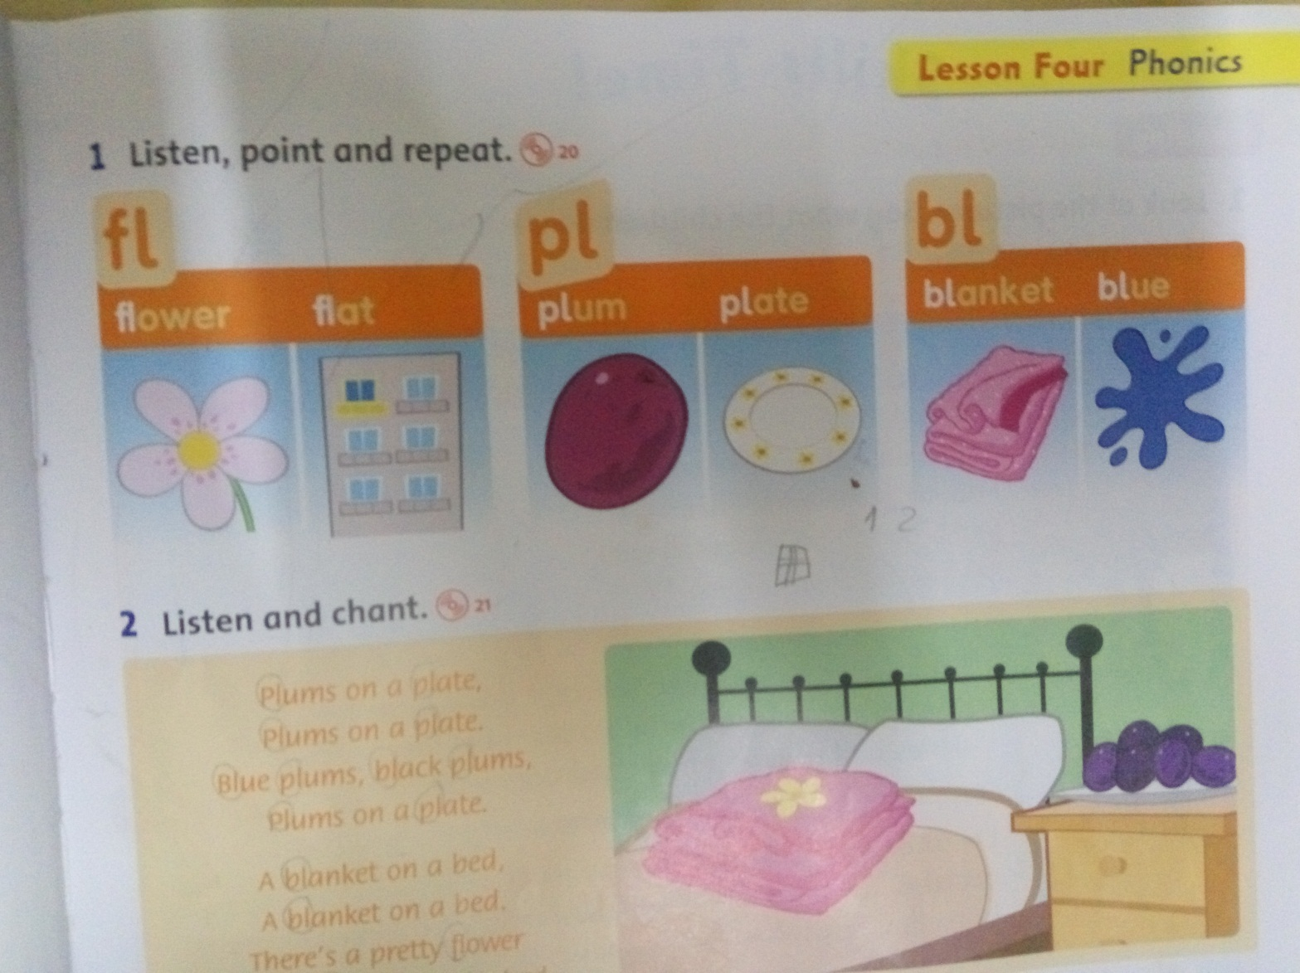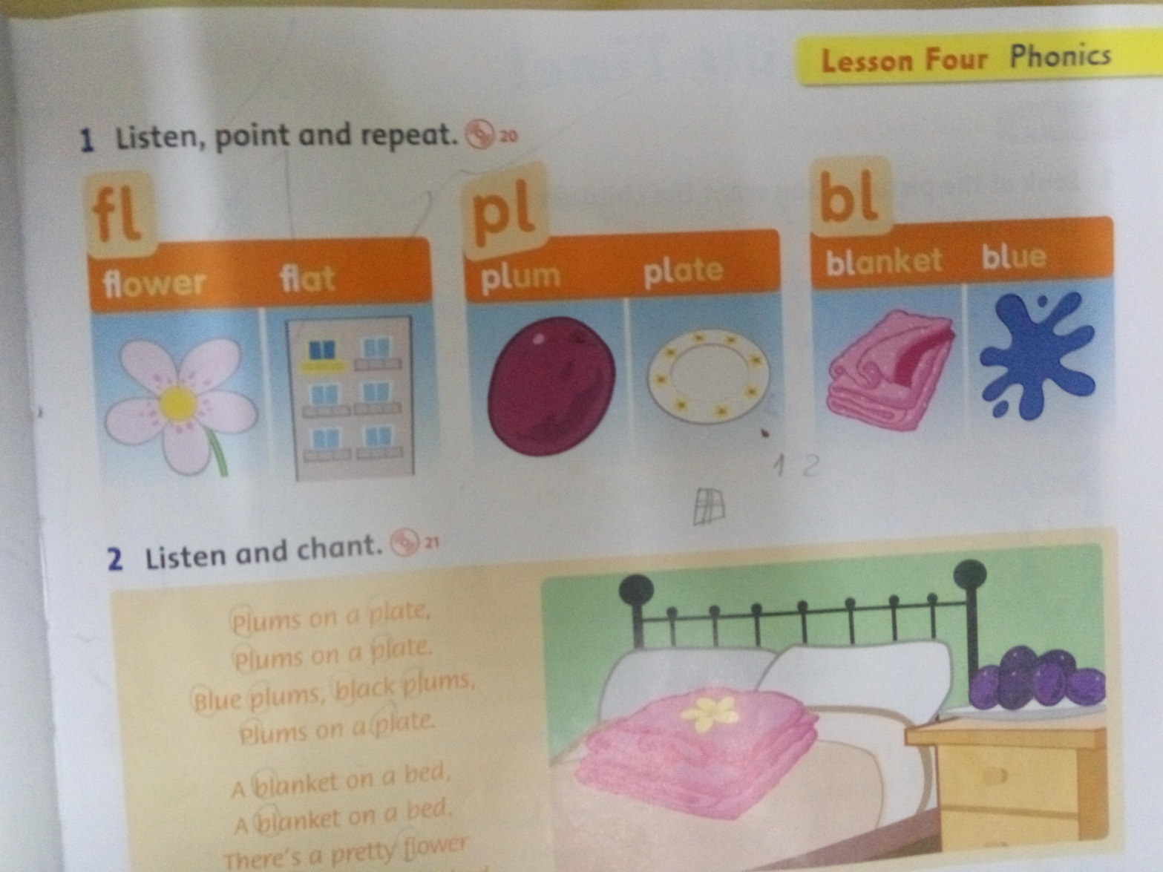

7. fl pl bl 8. fl pl bl

**III. Complete**

***our their***

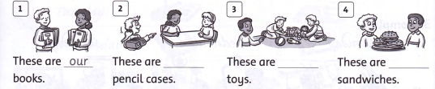

**IV. Find then underline the mistakes and correct**

1. My mum really like nuts and pastries. 🡺 My mum really likes nuts and pastries.

2. I don’t listens to music on Tuesday. 🡺 ………………………………………………………….

3. Anna don’t have a music lesson after school. 🡺………………………………………………………….

4. What do Herry like? 🡺 ………………………………………………………….

5. When have you got on Friday? 🡺 ………………………………………………………….

6. Ruby go home in the afternoon. 🡺 ………………………………………………………….

7. I have dinner on the evening. 🡺 ………………………………………………………….

8. What have you got Music? 🡺 ………………………………………………………….

9. I can goes swimming on Sunday. 🡺 ………………………………………………………….

10. My dad works in seven o’clock. 🡺 ………………………………………………………….

**V. Write the missing words to complete the passage.**

***get***

My name’s Anna. This is my day. I _____ up at six o’clock _____ the morning. I have _____ - bread and milk. Then I _____ to school _____ bus _____ eight o’clock.

My mum is ____ teacher. She works ______ seven o’clock. She ________ home at four ____ and she _______ dinner. My family has ________ in the evening. We go to _______ at night.