Name:…………………………………….
Class:………………………………………
ENGLISH GRADE 4 WORKSHEET – REVISION 2

I. Circle the odd-one-out.
1. a. straight b. curly c. little d. blond
2. a. big b. parrot c. tall d. short
3. a. long b. head c. neck d. ear
4. a. meat b. fish c. rice d. juice
5. a. pillow b. blanket c. bed d. square
6. a. computer b. pencil case c. rug d. board
7. a. classroom b. dining room c. living room d. balcony
8. a. draw b. bright c. climb d. sing
9. a. tidy b. drink c. eat d. walk
10.
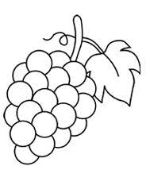
II. Look and write
1. 2.
triangle
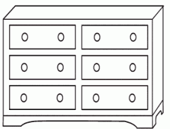
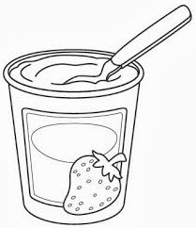
3. 4.

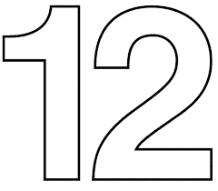
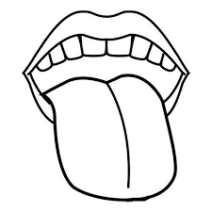
5. 6.

III. Read and write
water a board bread blond
a giraffe a tiger a rectangle

a giraffe
1. This animal is tall. It’s got two little ears on top of head.
2. It’s a kind of food that you usually have for breakfast.
3. You drink it every day.
4. This is a school thing. It’s on the wall in the classroom.
5. It’s got big teeth. It hasn’t got fingers.
6. It’s a word to describe the colour of hair.
7. It’s got two short sides and two long sides.
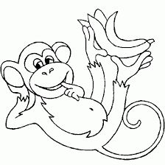
IV. Read and underline.
The monkey ( is / are / can ) little. It ( has got / hasn’t got / can’t ) two arms. It ( has got / hasn’t got / can ) big ears. It ( like / likes / has got ) bananas.
It ( don’t like / hasn’t got / doesn’t like ) meat. It ( is / can / can’t ) climb trees. It ( is / can / can’t ) fly.

V. Look and complete
