Name:…………………………………….

Class:………………………………………

**ENGLISH GRADE 1 WORKSHEET – REVISION 2**

**I. Choose and write**

*h i j k l m*

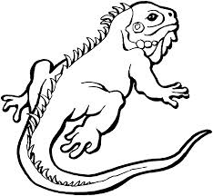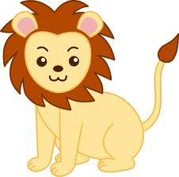

1. l ion 5. _______guana.

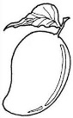

2. ______oon 6. _ _______ango

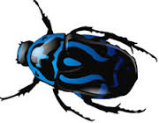

3. _______ump 7. ________nsect

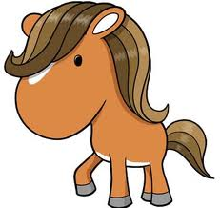

4. _______emon 8. ________orse

**II. Answers *How many……..***

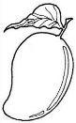********1. mangoes?

nine

2. lemons?



3. lions?

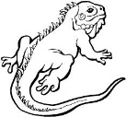4. iguanas?



5. insects?

**III. Look. Read then write “Yes” or “No”**

|  |  |  |  |
| --- | --- | --- | --- |
| 1. |  | It’s an iguana. | _______________  Yes |
| 2. | images (25)images (25) | Four insects. | _______________  No |
| 3. | tải xuống (18) | It’s the sun. | _______________ |
| 4. | 87tải xuống (19) | It’s a mango. | _______________ |
| 5. |  | It’s a donkey. | _______________ |
| 6. | tải xuống (17)tải xuống (17)tải xuống (17)tải xuống (17)tải xuống (17)tải xuống (17)tải xuống (17) | Eight lemons. | _______________ |

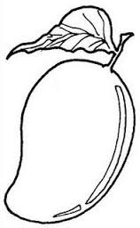

**IV. Colour**

1. Colour the mango in green.

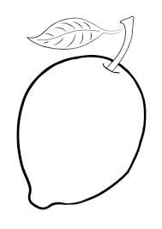

2. Colour the lemon in yellow.

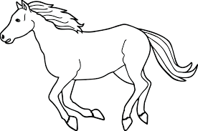

3. Colour the horse in orange.